Practical-13
PHP JSON API and AJAX/Fetch-Based CRUD without Page Reload
Theory
1. Do PHP endpoints return valid JSON responses?
Answer: Yes. The events_list.php GET endpoint returned a JSON object containing success: true, a message and a data array of event records. The response was inspected in Chrome Developer Tools.
2. Are GET and POST requests handled properly?
Answer: GET requests loaded events through the Fetch API with HTTP 200. The Add, Update and Delete forms also displayed successful asynchronous results. Separate POST status-code screenshots were not captured.
3. Are loading, success, and error states shown on the frontend?
Answer: Yes. The interface displayed Connected, Loading..., green success notifications for CRUD and a red validation message for an empty title. Events were updated without a full page reload.
4. Is input validation performed before database operations?
Answer: Yes. Empty title submission was blocked with the message "Enter at least 2 characters for title." The PHP API source also includes input checks, although a separate server-side invalid-request test was not recorded.
Result:
A PHP JSON API and JavaScript Fetch-based Event Management module was implemented in StudentHub. The GET API returned event records successfully. In the browser, one test event was added (23 to 24 events), edited, and deleted (24 to 23 events) without page reload. Debounced live search returned one matching result, and a blank title produced a validation error.
Evidence of Work (Screenshots)
The following original screenshots show SQL import, the event dashboard, GET network/JSON evidence, asynchronous add/update/delete actions, live search and frontend validation. Only observed results are reported.

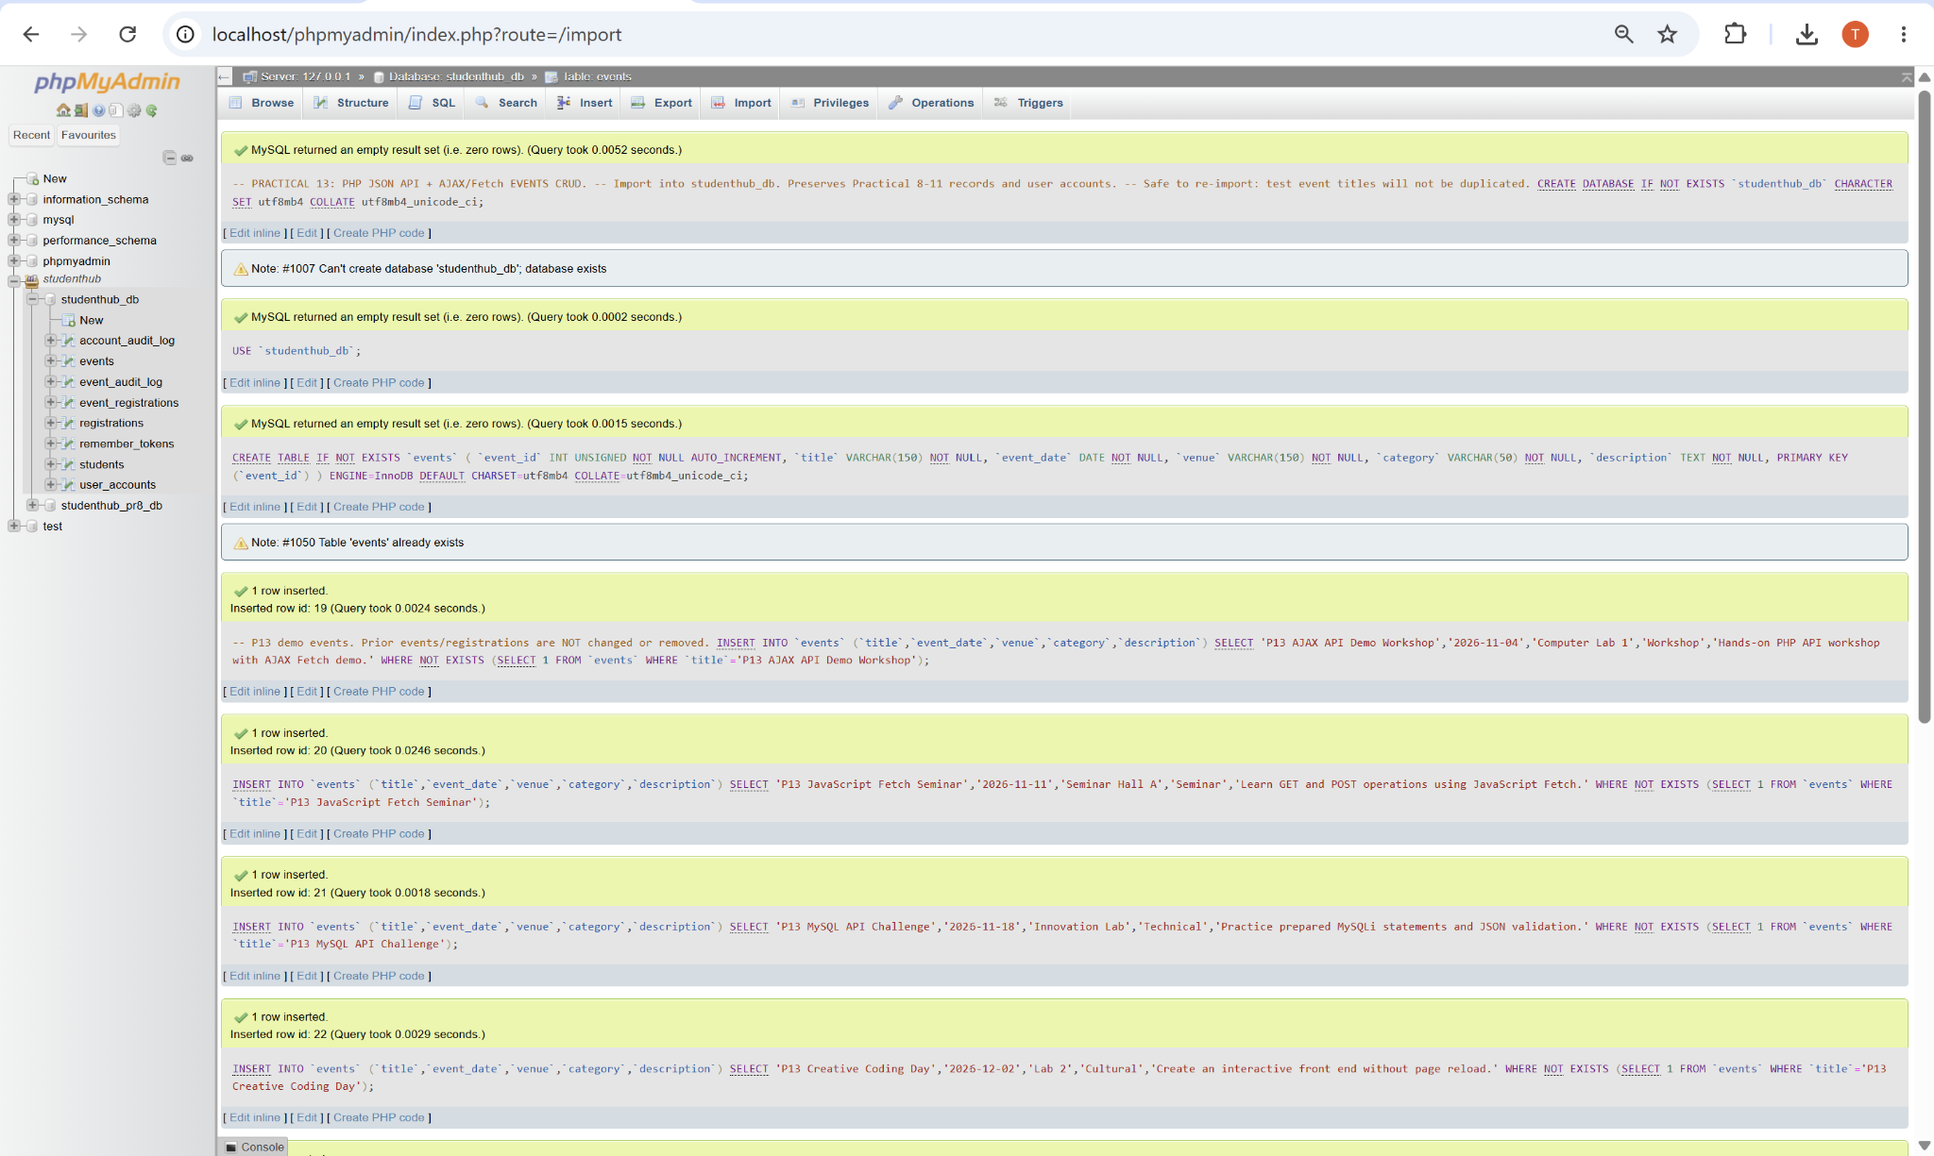
Figure 1: Practical 13 SQL Import and Sample Event Records
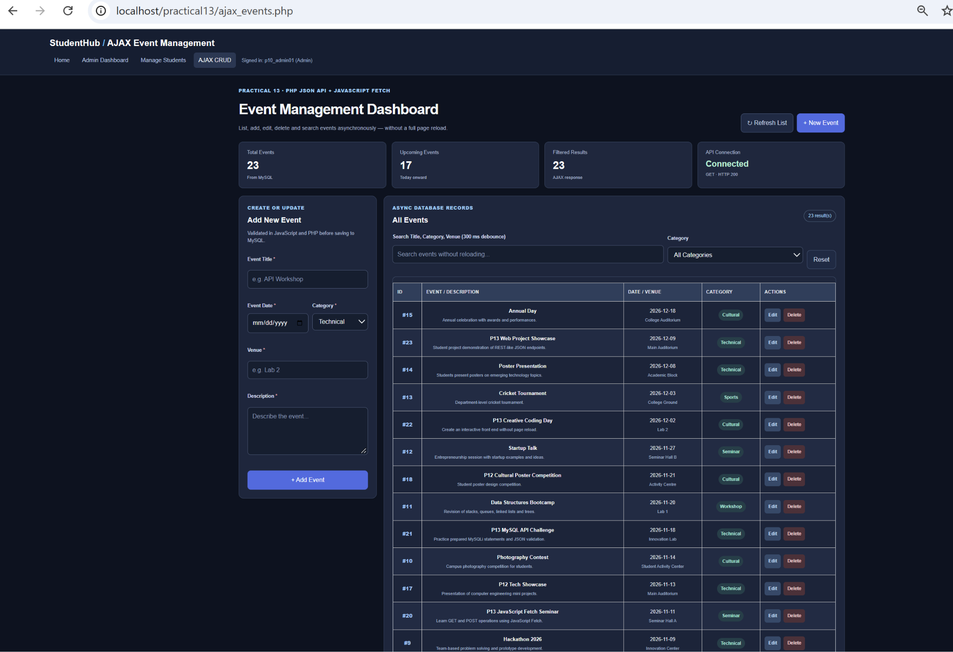
Figure 2: AJAX Event Management Dashboard - Connected API and 23 Events

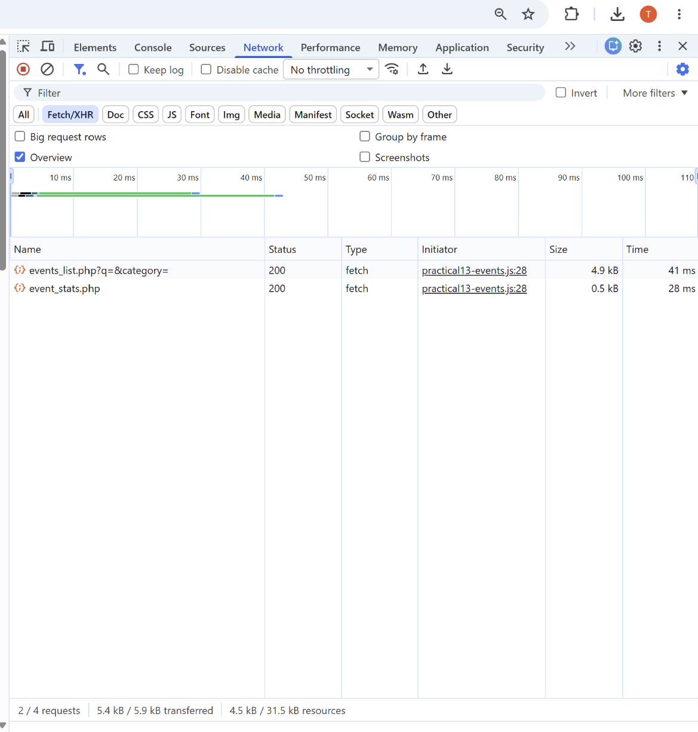
Figure 3: Fetch/XHR GET Requests Returning HTTP 200
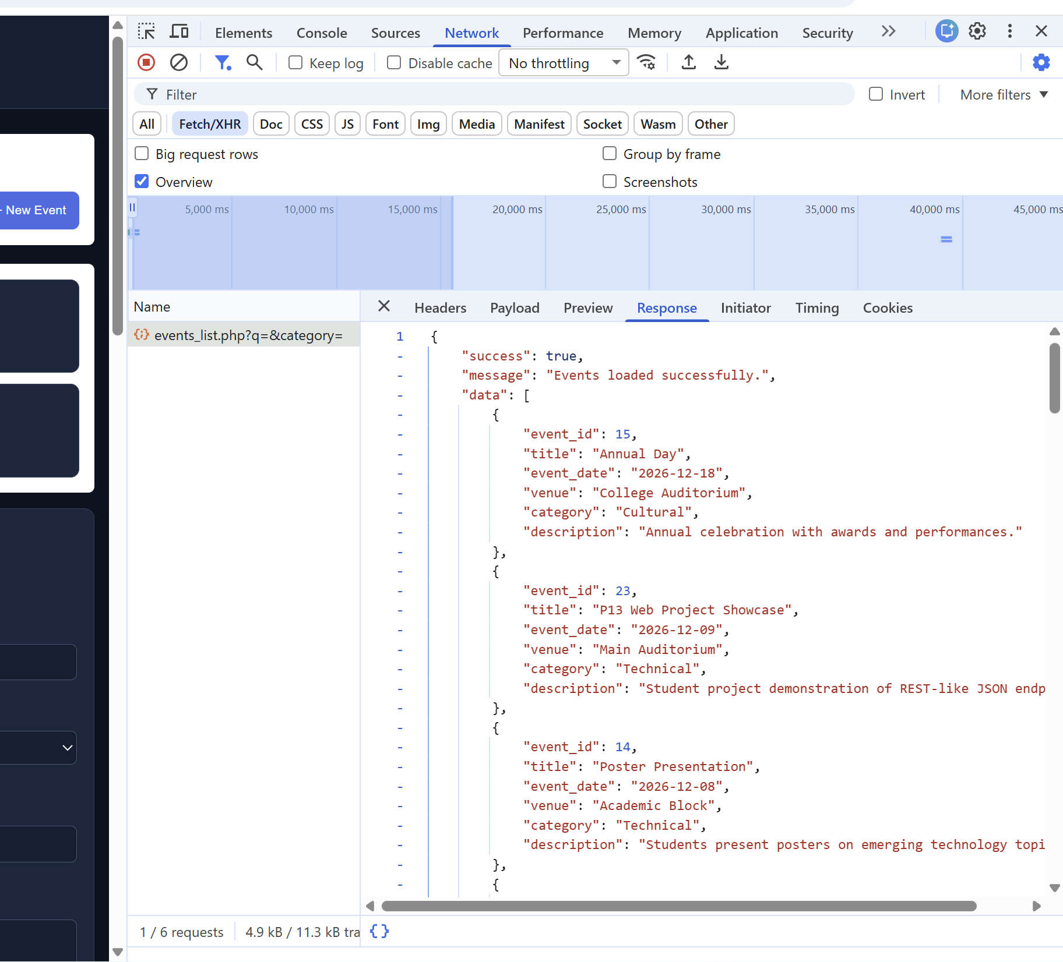
Figure 4: GET API JSON Response - success: true and Event Data

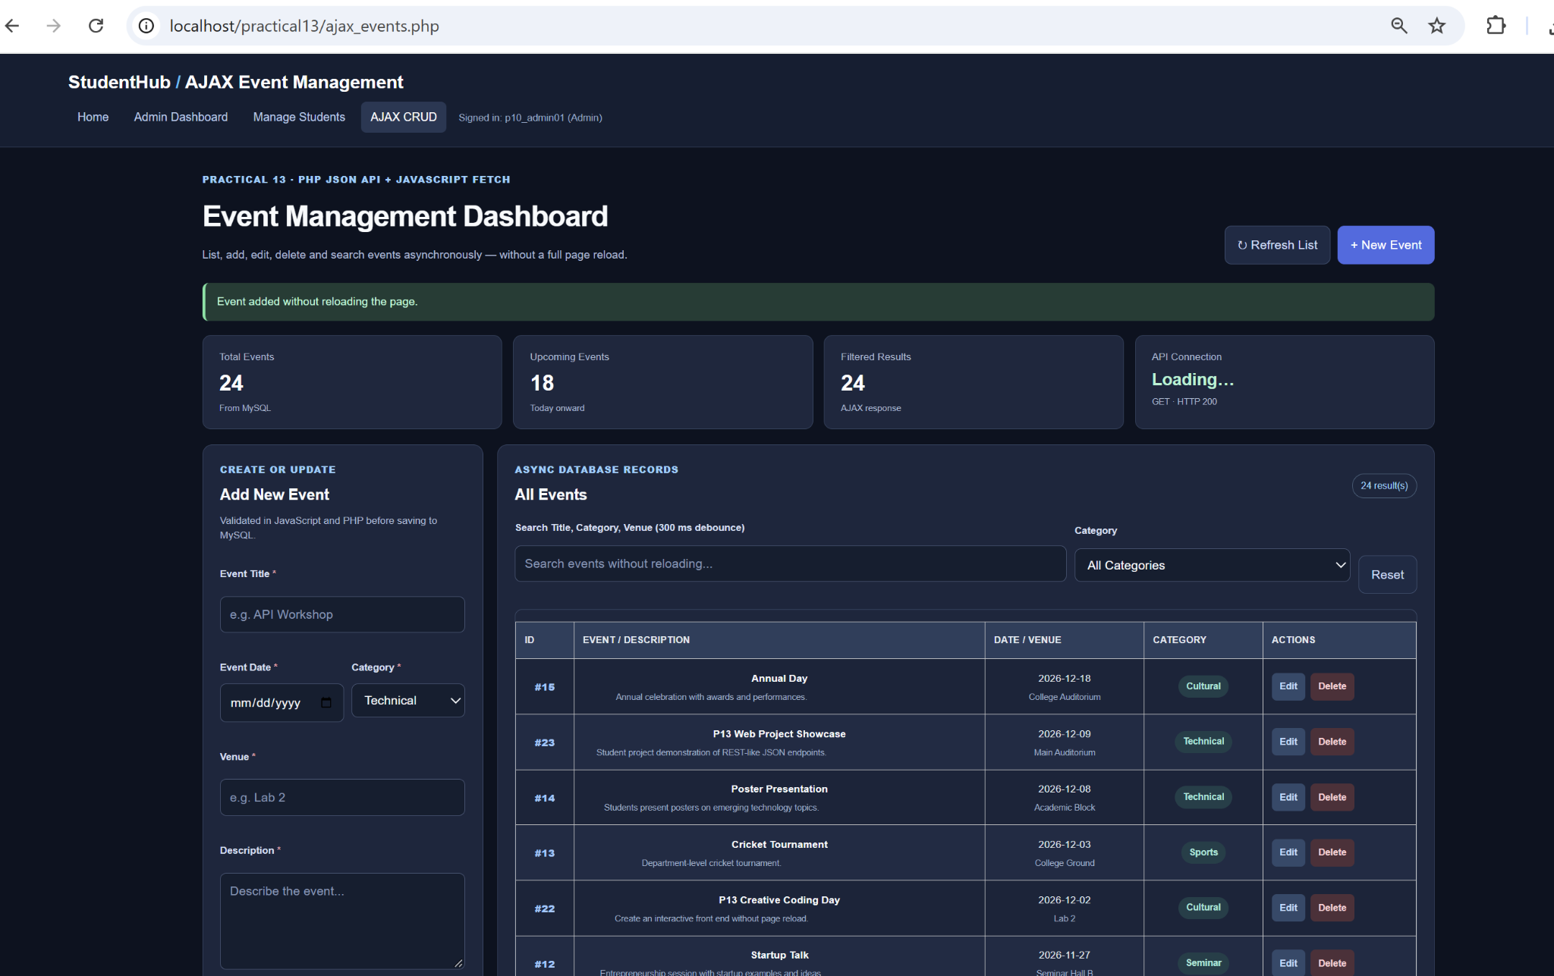
Figure 5: AJAX Add Event Success - Total Events Increased to 24
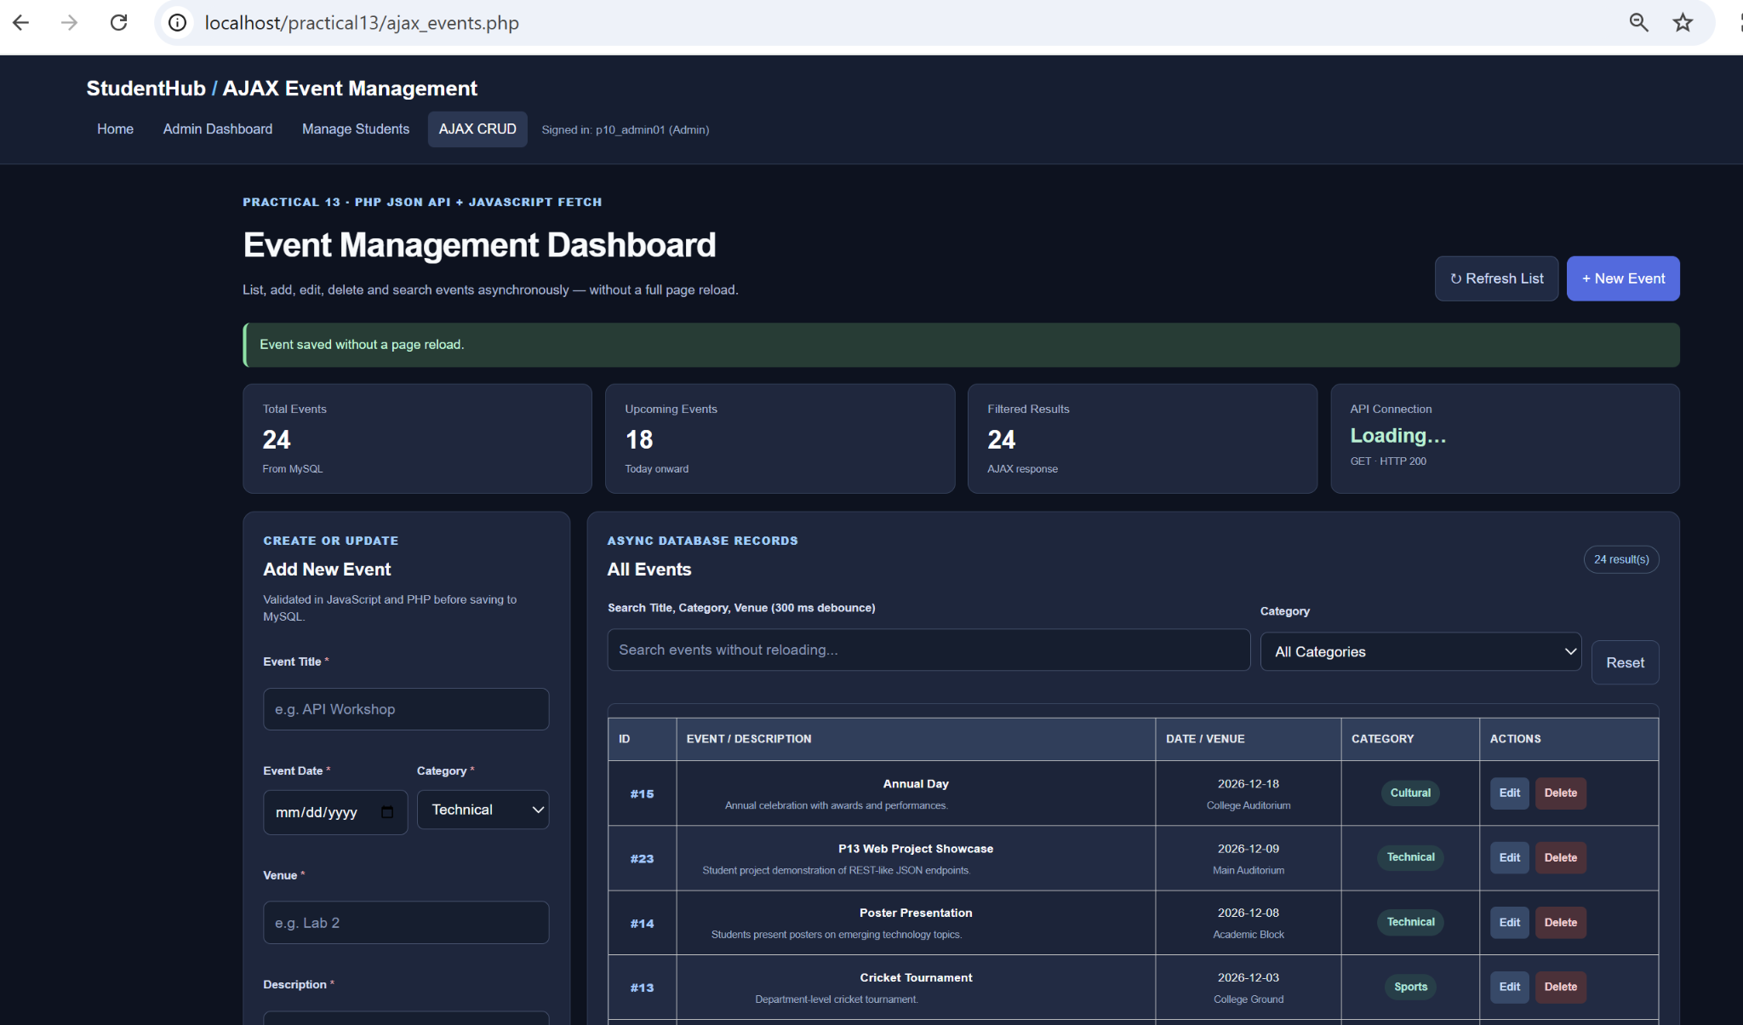
Figure 6: AJAX Update Confirmation - Event Saved Without Page Reload

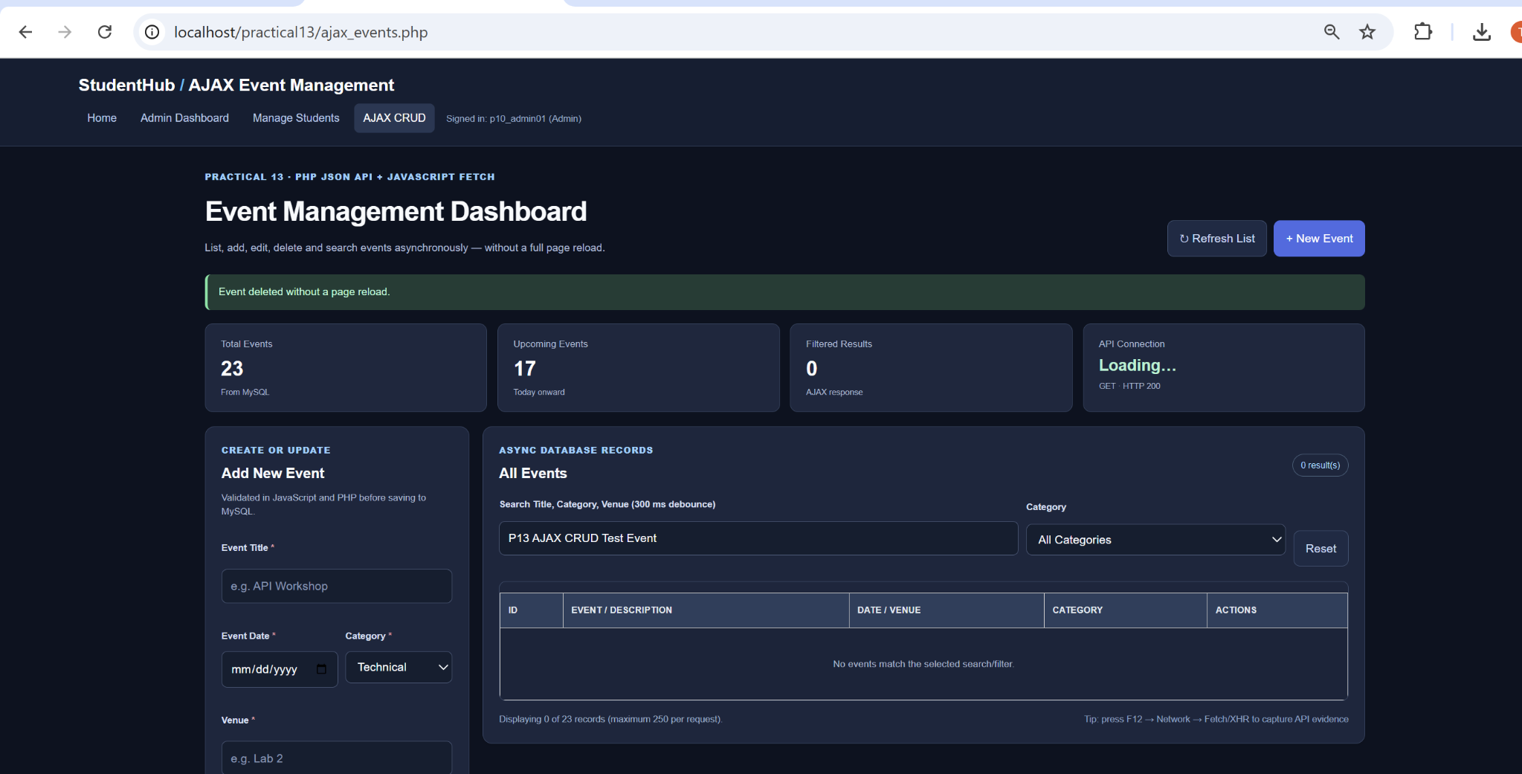
Figure 7: AJAX Delete Success - Total Events Returned to 23
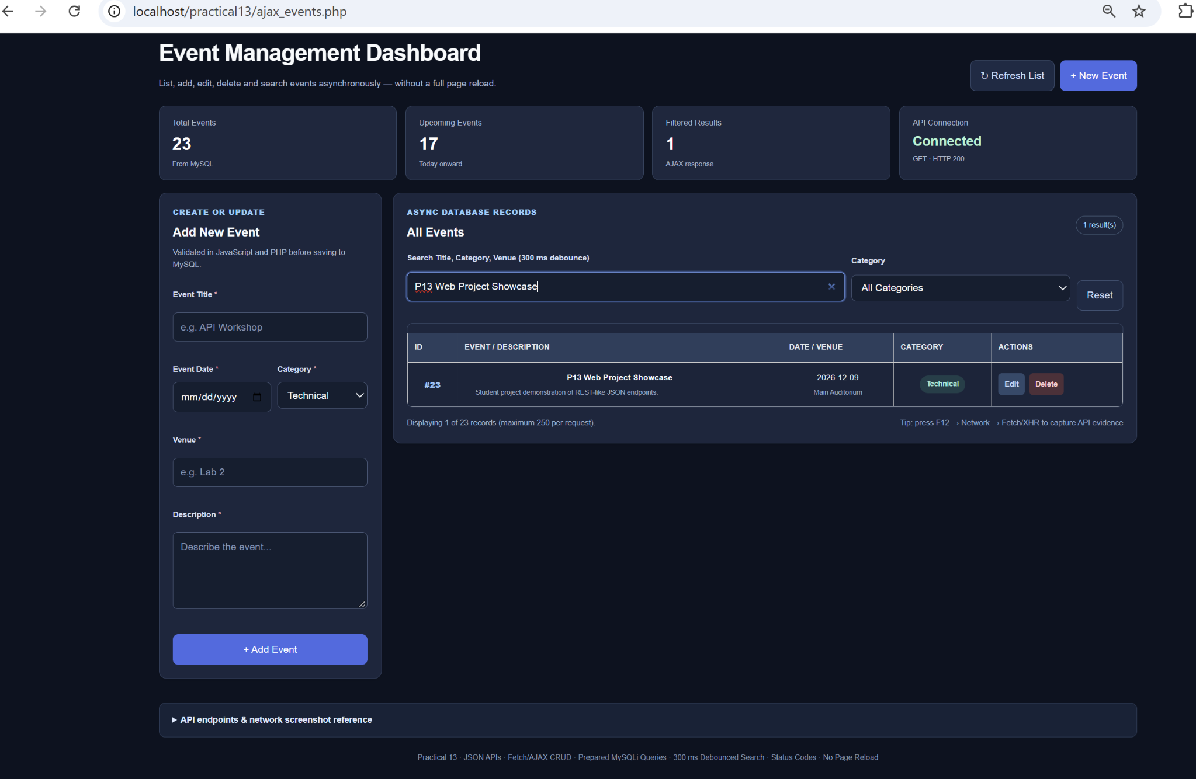
Figure 8: Live Search Using 300 ms Debounce - One Matching Event

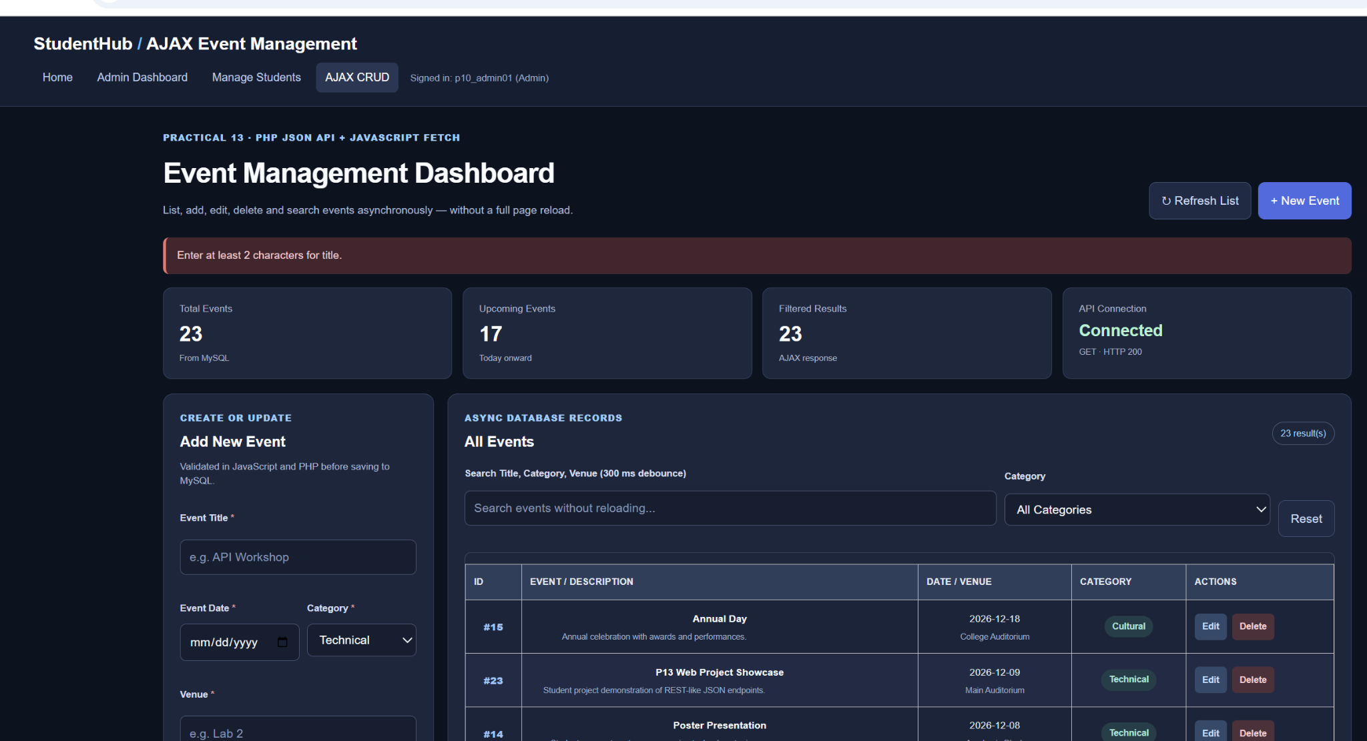
Figure 9: Frontend Input Validation - Empty Event Title Rejected
The red validation message stopped an empty title submission. Total Events stayed at 23. This screenshot demonstrates frontend validation; a separate invalid POST response was not captured.

A. GitHub Repository Link:
https://github.com/adrojatarang8-art/StudentHub
B. Challenges Faced:
• I used the correct practical13 folder URL under XAMPP and signed in with the administrator account.
• I imported the Practical 13 sample-event SQL into the existing studenthub_db while retaining previous data.
• I corrected a PHP 8.0 compatibility problem that initially caused a non-JSON response from the POST API.
• I fixed the light dashboard panels to match the StudentHub dark theme.
• I verified the Fetch/XHR requests and tested CRUD, search and validation using the browser.
C. Learning Outcome:-
I learned how PHP endpoints send JSON data to JavaScript and how the Fetch API connects an interactive frontend to a MySQL database. I practiced listing, adding, updating and deleting events without reloading the page, checking API responses in Chrome Network tools, using debounced search, and displaying loading, success and validation messages.
Verification Note:
The browser screenshots verify GET JSON output and visible asynchronous CRUD results. Individual POST response payload/status screenshots and a server-side invalid-request test were not supplied; they are not claimed as independently verified.
Faculty Remarks:

